# Multilevel Inheritance in Python

Multilevel inheritance is also possible in Python unlike other programming languages. You can inherit a derived class from another derived class. This is known as multilevel inheritance. In Python, multilevel inheritance can be done at any depth.

**Image representation:**

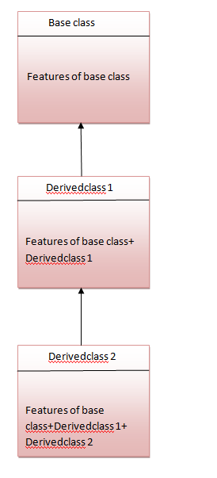

## Python Multilevel Inheritance Example

1. class Animal:
2. def eat(self):
3. print 'Eating...'
4. class Dog(Animal):
5. def bark(self):
6. print 'Barking...'
7. class BabyDog(Dog):
8. def weep(self):
9. print 'Weeping...'
10. d=BabyDog()
11. d.eat()
12. d.bark()
13. d.weep()

**Output:**

1. Eating...
2. Barking...
3. Weeping